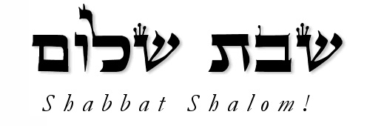

September 19, 2026

, 2021
SHABBAT SERVICE
7th day of 7th Month
11:OO AM

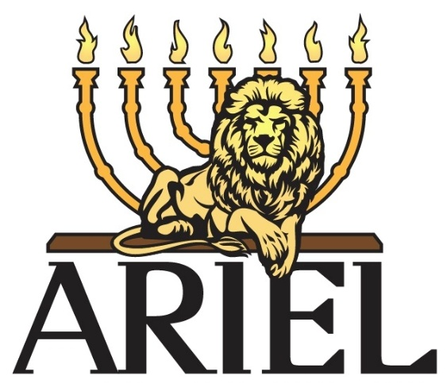

A TORAH BASED MESSIANIC CONGREGATION


TORAH:
Ha-azinu
Deuteronomy
(Deuteronomio)
32:1-52
HAFTORAH:
Hosea (Oseas) 14:1-9;
Joel 2:15-27

ARIEL
1525 E. Graves Avenue
Orange City, FL 32763
(386) 956-4559
E-MAIL shma30@hotmail.com
www.arielcongregation.org
A Multicultural Hearing and Deaf Congregation

Torah Study Guide
Sukkot
Leviticus, Deuteronomy, and Zechariah



Leviticus (Levitico) 23:33-44
1. On the first day of Sukkot, you shall take what
and rejoice before Yah?

2. Why are the people to dwell in booths?

Deuteronomy (Deuteronomio) 16:13-17
3. What standard it given for how we should give at
the feasts?

Zechariah (Zacarias) 14:16-21
4. Who is to go up to Jerusalem every year at
Tabernacles?

5. What will the punishment be for not going up to
Jerusalem at Tabernacles to worship the
king?

Ariel is a member of the
International Federation of Sephardic and Ashkenazi Jews
Paul Falk: Messianic Rabbi
Mary Hoover & Erika Figueroa: Board Members

SUKKOT ACTIVITIES
Dinners start at 6 p.m. most nights
(please sign up for what you want to bring if possible)

Sept. 27—Sandwiches White Elephant
Sept. 28—Italian RP’s Dance Class
Sept. 29—Mexican Movie Night
Sept. 30—Chili Feast Ask the Rabbit
Oct. 1—RP’s Famous Pancakes Game Night
Oct. 2—Brisket
Oct. 3—Leftovers Night

REMINDERS
Oneg: All guests are welcome to join us for Oneg, a light lunch after service. This is a great opportunity to meet some new people and discuss the scriptures. Remember, our guests get to go through the line first!

Tehillim Circle is a circle of prayers for healing created to enable our congregants to help those in need by collectively engaging in the recitation of the psalms. For more information see Rabbi Paul or Diane or email pdf95@hotmail.com.

Notes
__________________________________________________________________________________________________________________________________________________________________________________________________________________________________________



“Behold, I [am] with you and will keep you wherever you go, and will bring you back to this land; for I will not leave you until I have done what I have spoken to you.”
Genesis 28:15

Torah ?’s: 1) Lev. 23:40; 2) Lev. 23:43; 3) Deut. 16:16-17;
4) Zech. 14:16; 5) Zech. 14:17-18.


MARK YOUR CALENDARS
Dance 101 Today 2:15ish
Ask the Rabbi Today 2:30ish
Mikvah (DeLeon Springs) Sept. 20 Sun., 9 AM
Mitzvah Class Sept. 26 2:30ish
ASL Class Sept. 26 2:30ish
Birthday Oneg Sept. 26 During oneg

Possible Fall Moedim ???
Erev Yom Kippur Sept. 21 Mon., 7 PM
*Yom Kippur Sept. 22 Tues., 11 AM
*Sukkot-1st day Sept. 27 Sun., 11 AM
*Sukkot-8th day Oct. 4 Sun., 11 AM
*These are the days to take off from work

